**Holiday Emergency Heating System (HEHS) Standard Operation Procedure of RoMag**

Yufan Xu

Safety has always been the priority of SpinLab. In case of holidays and other special occasions when no one is physically around RoMag, one should implement Holiday Emergency Heating System (HEHS). HEHS is consist of a Yeti Lithium Battery, 2 Inkbird thermostats, and three heating tapes. And the monitoring can be access remotely from the remote desktop applications or VNC connectors. See appendix for the details of those components.

**HEHS schematics**

HT 3

HT 1

HT 2

Inkbird 1

Inkbird 2

Yeti

Fig 1. The schematics of HEHS.

The Yeti battery is constantly charging and providing power to the Inkbird thermostats and heating tapes. The Inkbird controls the heating tapes and constantly monitoring the heating temperature from the thermistors. Two heating tapes are wrapped around the expansion tank and the cornered expansion tube to prevent freezing from the top. Another heating tape is wrapped around the tank and is set to heat near the 30C. It only starts heating when the tank’s temperature drops significantly to prevent freezing inside of the tank. In addition, the SERVO should be turned off from the fuse box to prevent rotation of the apparatus. And the table should be mechanically jammed to prevent rotation.

**Status Update, Alarms, and Daily Routine**

1. **Status Update**

The monitoring LabVIEW program for RoMag is set to send a status update every 30 minutes. Please check email frequently and pay attention to the following procedure.

The following email is an example:

*“TopTemp is 36  
BottomTemp is 36  
Expansion Tank Temp is 72*

*Power is 16  
The primary responder is*[*yufanxu@ucla.edu*](mailto:yufanxu@ucla.edu)[*608-886-7181*](tel:608-886-7181)*.”*

Upon receiving the email update, make sure all the temperature and power parameters are in the correct range. If one hasn’t received the emails over 30 minutes, remote access is required, and other lab personals should be noticed.

**Situation 1:** **No Email/LabVIEW Errors.**

If one stop receiving the update emails, remotely access to the RoMag computer. Normally there is some error with the LabVIEW, simply restart the program, and the system should work fine. If the PXI stopped working, follow the procedures for Power Outage.

**Situation 2:** **Power outage.**

If one stop receiving the update emails, or the power parameter in the update is 0. The alarm will be trigged, and one should first remotely access to the RoMag computer to check if the heat pad power supply is still functioning or not. If the remote access is denied, there is possibly a power outage (or a malfunctioning PC). Unfortunately, if there is a power outage, the closest lab personnel would need to come into the lab and make sure everything is still functioning under the Yeti battery. Follow the checking procedures in the next section.

**Situation 3: Temperature parameters change significantly.**

If the temperature parameters change significantly, one should remotely access the LabVIEW program before the alarm goes off. Contact other lab personals and make decisions immediately.

1. **LabVIEW Alarms**

LabVIEW alarms will go off if the temperature and power parameters are off the potential range. Once triggered, the alarm will go off and send email updates (titled “***** Romag Labview Alarm ******”) every 2 minutes. Upon receiving the alarms:

1. Contact other lab personals immediately and describe the situation.
2. Remotely access to the lab’s computer to estimate the cause.
3. Remotely access to the fume hood PC and observe via the cameras.
4. If an emergency has confirmed, the closest person to the lab should head to the lab immediately.

**Situation 1: Heat Pad Power Supply Malfunction.**

If the power parameter is out of range, shut down the heat pad power supply immediately from the remote desktop. Find the control LabVIEW program on the desktop and change the power output to “0”. The heat tape should be activated and prevent gallium from freezing. Then the person closest to the lab should come in and try to fix the power supply.

**Situation 2: Inkbird/ Heating Tapes Malfunction.**

Use LabVIEW to locate the malfunction: For example, if the sidewall temperature rises abruptly, remove the sidewall heating tape and troubleshoot the Inkbird/thermistors. The Inkbird will automatically shut down if the temperature is too high.

**Situation 3: Chillers Malfunction.**

If the top and bottom lids temperature rise significantly, the chillers might have stopped working. Remotely access to the fume hood PC and observe via one of the cameras. The temperature of the lab chiller should be clear on the screen. If a malfunction signal goes off, or the chiller shut down itself. Shut down the heat pad power supply immediately to prevent overheating. The heat tape should prevent gallium from freezing. The closest person to the lab should come in and try to fix the chiller. Double check if the rooftop chiller is still functioning. If not, contact the specialists to fix the chiller.

**Situation 3: Yeti Malfunction.**

The robust Yeti could also have problems, believe it or not. If Yeti stops working, switch the power cables to an extension cord and connect it to the power outlet on the wall.

**Situation 4: Natural Disasters.**

Whenever there is a natural disaster occurs on campus (earthquakes, fires). Frequently and remotely monitor the status of the device. Follow the instructions from the authorities.

1. **DDC Alarms**

The currently working DDC alarm is the water bugs. The alarm goes off if it detects water under the RoMag device. In this case, contact other lab personals immediately and describe the situation. The person closest to the lab should come in and clean the excess water and try to fix the leak.

1. **Daily Routine**
2. Remotely access to both of RoMag’s PCs every day from time to time. One can use VNC viewer on the mobile device.
3. Observe if there is smoke, burn marks on the insulation or other abnormal phenomenon.
4. Report to other lab personals every day.

**Appendix A. RoMag Lab Frame Wiring Diagram (Grannan’s Thesis)**

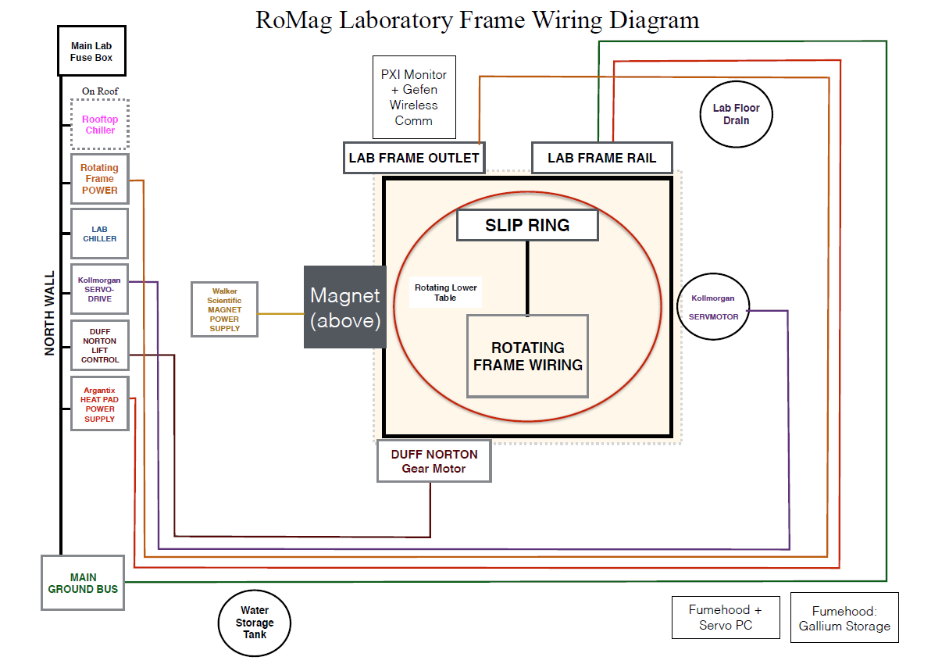

**Appendix B. The Fuse Box (Grannan’s Thesis)**

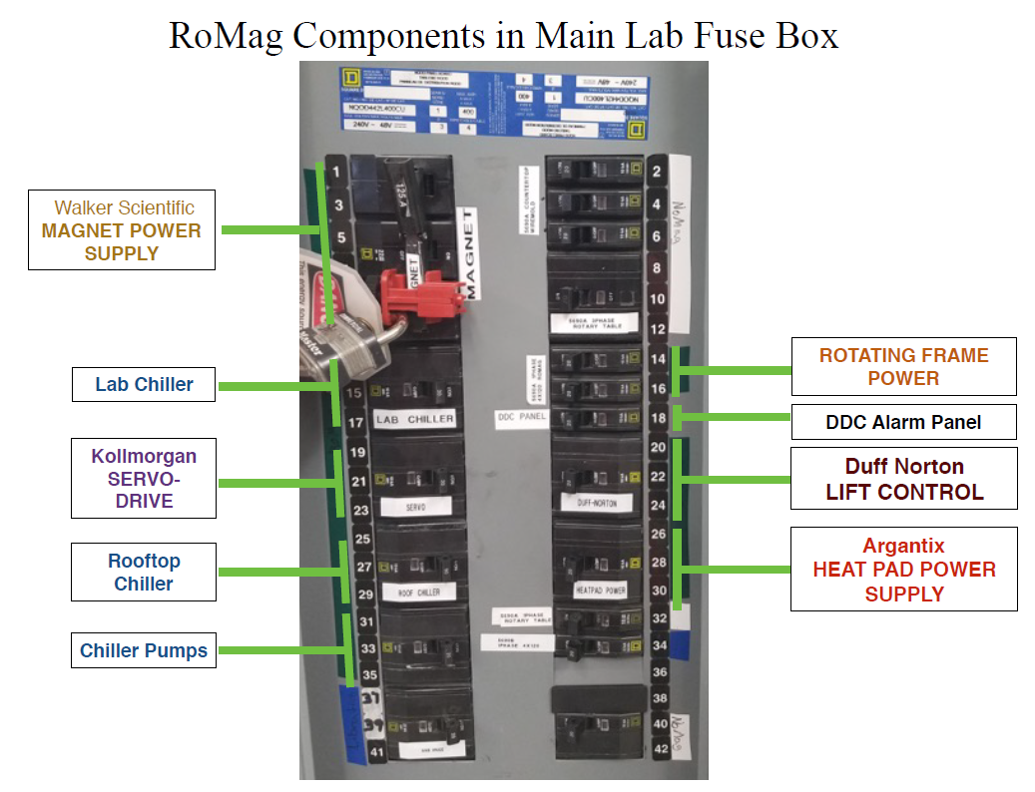

**Appendix C HEHS Components:**

1. **Goal Zero® Yeti 400 Lithium Portable Power Station**

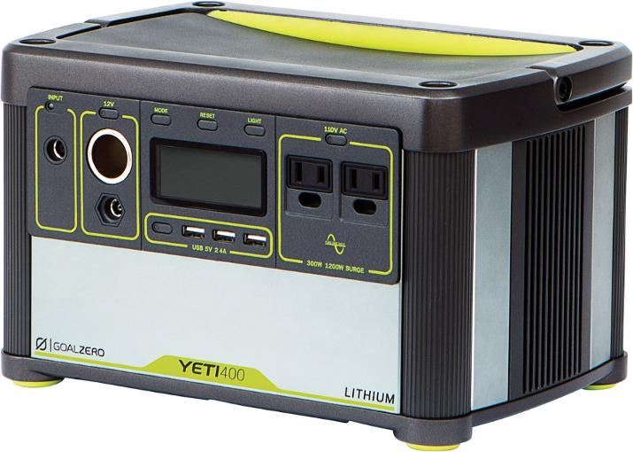

### Features

* Quiet, portable power station recharges from the sun with a Goal Zero solar panel (sold separately) or from a wall outlet
* More powerful than its predecessors, the Yeti 400 features increased surge allowances, advanced battery protection, user-replaceable lithium battery pack and longer shelf life
* 428-Wh battery capacity with 39.6Ah and 10.8V is ideal for powering lights, smartphones, tablets, laptops, a mini fridge, TV and portable medical devices
* 4 USB power outputs and 2 AC power outputs let you power up multiple devices at the same time
* Fully charged, the Yeti 400 offers the following approximate power: headlamp (100 charges); smartphone (30+ charges); laptop (3-5 charges; tablet (10+ charges)

### Technical specs

|  |  |
| --- | --- |
| **Best Use** | Camping |
| **Charge Time (hrs)** | Wall: 7; solar: 14 - 16 hours |
| **External Charge** | Wall |
| **Battery Included** | Yes |
| **Battery Type** | Lithium Ion |
| **Battery Storage Capacity (mAh)** | Unavailable |
| **Power Output To Device (mA)** | Unavailable |
| **Material(s)** | Aluminum/ABS plastic |
| **Dimensions** | 11.25 x 7.5 x 7 inches |
| **Weight** | 16 lbs. 4.8 oz. |
| **From Website:** |  |

[**https://www.rei.com/product/123285/goal-zero-yeti-400-lithium-portable-power-station?CAWELAID=120217890004029254&CAGPSPN=pla&CAAGID=15877485520&CATCI=aud-87986356584:pla-370969241007&cm_mmc=PLA_Google|404_67551|1232850001|none|33341d8a-e4c1-48d2-9ef1-c4ac4c089f9c|aud-87986356584:pla-370969241007&lsft=cm_mmc:PLA_Google_LIA|404_67551|1232850001|none|33341d8a-e4c1-48d2-9ef1-c4ac4c089f9c|aud-87986356584:pla-370969241007&gclid=CjwKCAiAsejRBRB3EiwAZft7sORxapGvxXMu9fUG9ESqP0Q-xz0OHt-Ur9SihDTsx3D15aeivwCYSRoCgPsQAvD_BwE**](https://www.rei.com/product/123285/goal-zero-yeti-400-lithium-portable-power-station?CAWELAID=120217890004029254&CAGPSPN=pla&CAAGID=15877485520&CATCI=aud-87986356584:pla-370969241007&cm_mmc=PLA_Google|404_67551|1232850001|none|33341d8a-e4c1-48d2-9ef1-c4ac4c089f9c|aud-87986356584:pla-370969241007&lsft=cm_mmc:PLA_Google_LIA|404_67551|1232850001|none|33341d8a-e4c1-48d2-9ef1-c4ac4c089f9c|aud-87986356584:pla-370969241007&gclid=CjwKCAiAsejRBRB3EiwAZft7sORxapGvxXMu9fUG9ESqP0Q-xz0OHt-Ur9SihDTsx3D15aeivwCYSRoCgPsQAvD_BwE)

1. **Inkbird Digital Temperature Controller Thermostat ITC-306T**

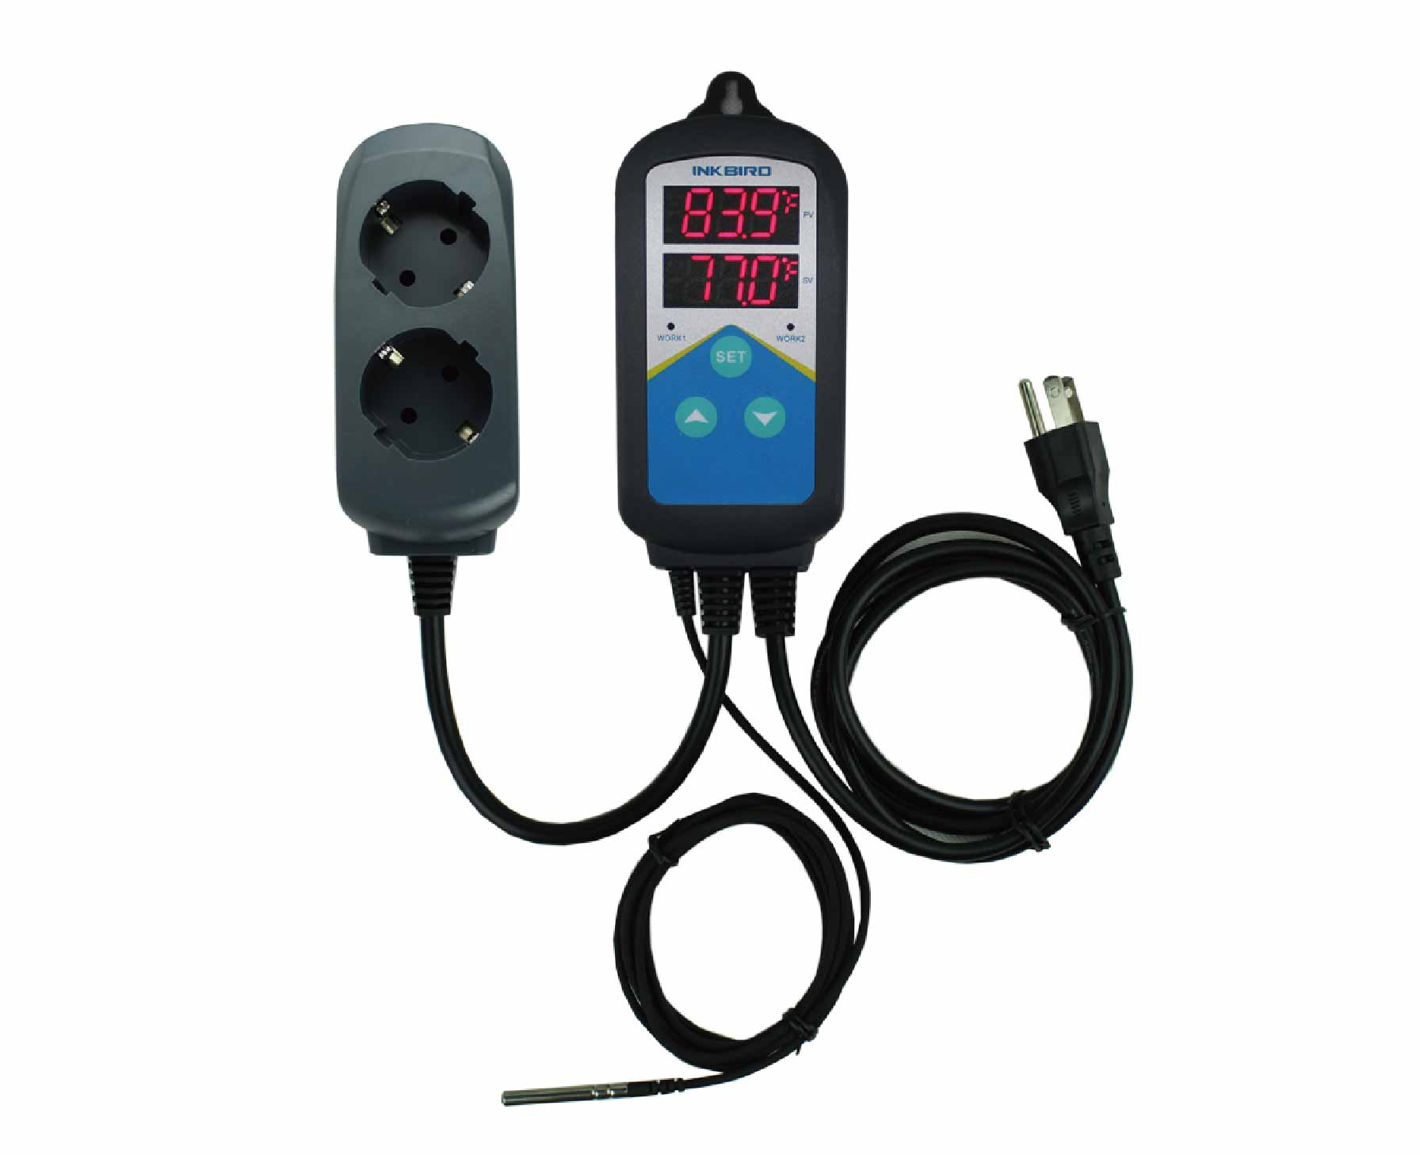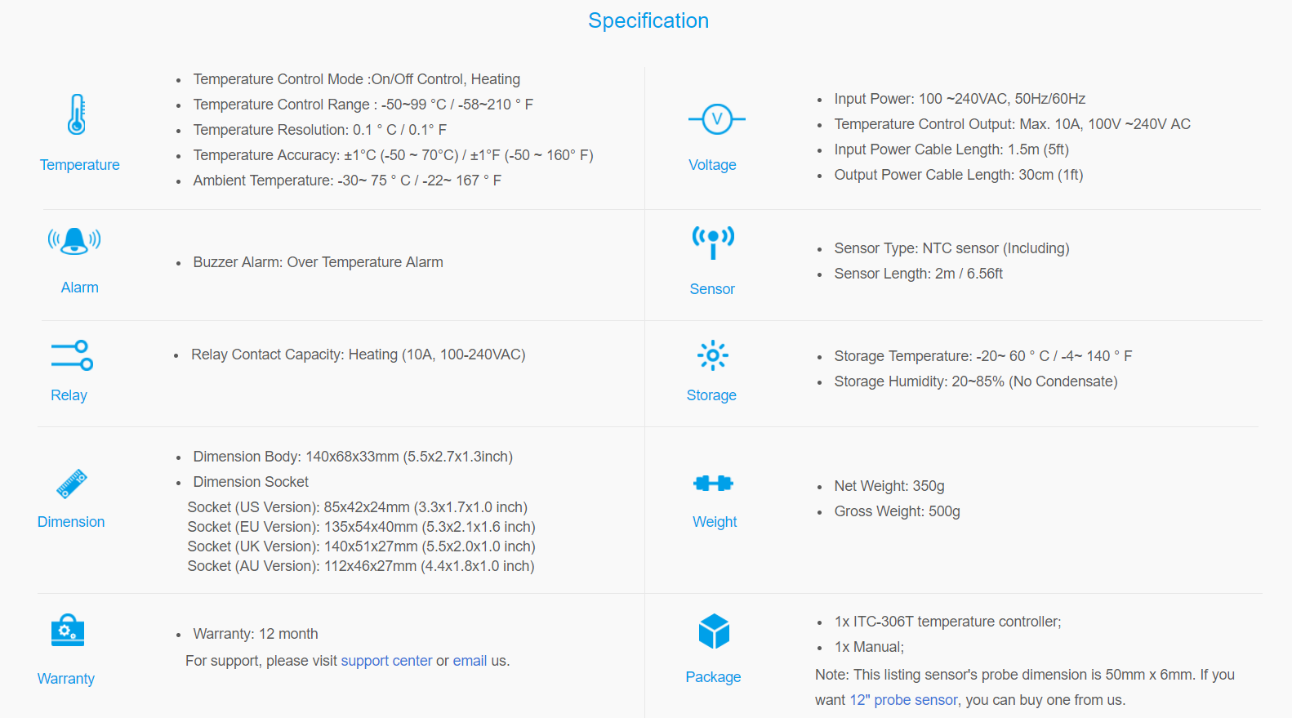**From http://www.ink-bird.com/products-temperature-controller-itc306t.html**

1. **Heating tapes: BriskHeat BS0101040L XtremeFLEX BS0 Silicone Rubber Heating Tape**

1"x 4' long; 209 watts; 120VAC

450F max temperature & moisture and chemical resistant

Silicone rubber with multi-stranded heating element

From Amazon.

